Year 4 Homework | Autumn Term 1
Homework activities for this half term are described below. You will receive Dojo Points for completing the tasks. When you complete a task, ask an adult to sign and date next to the task description.
All attempted tasks need to be completed and returned by Friday 14th October 2022.
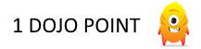
Timestables! Visit https://www.timestables.co.uk/multiplication-tables-check/ and have a go at 25 question challenge! | English! Create an acrostic poem about the Romans. | 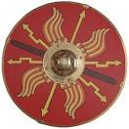  Topic! The romans are invading! Create a roman shield (like the one below) to protect yourself in battle!
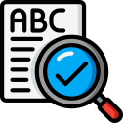  Spellings! Pick 10 of the 100 Year 4 spellings and write a story using all the words! | Science! Draw and label a picture of the water cycle. | Science! Create a fact poster describing Thomas Edison and the amazing work he did with Electricity!
Reading! Read 5 times in one week! Don’t forget to write it in your reading diary. | Writing! Write a paragraph about your favourite book, explaining why you enjoyed it! (Remember, try not to spoil the ending!) | Art! Use pictures to create a storyboard of a book you have read. It must have at least 6 squares and be drawn in pencil.

