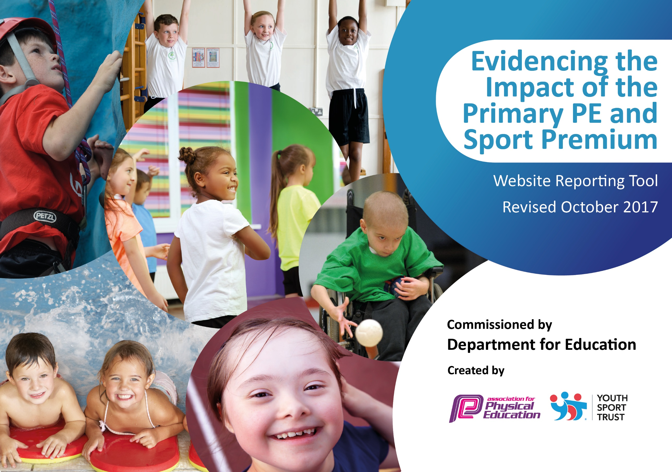

Schools must use the funding to make additional and sustainable improvements to the quality of PE and sport they offer. This means that you should use the Primary PE and Sport Premium to:

- develop or add to the PE and sport activities that your school already offers
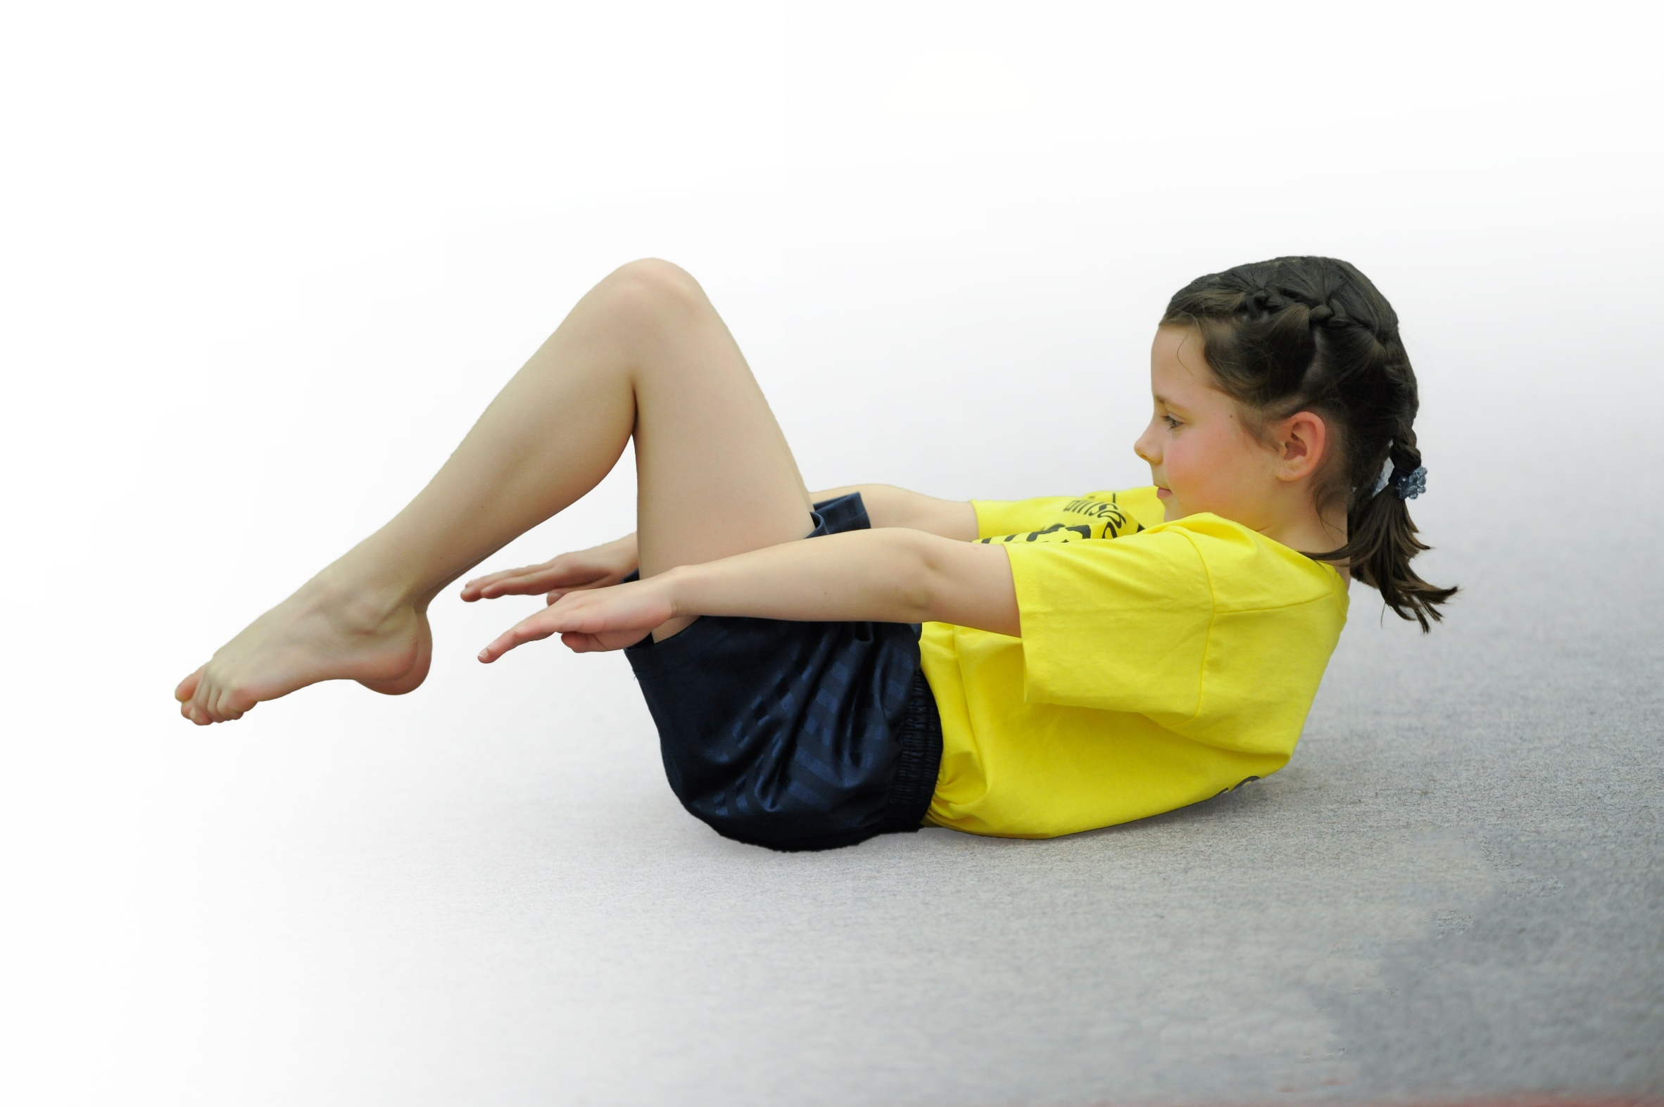
- build capacity and capability within the school to ensure that improvements made now will benefit pupils joining the school in future years

Please visit gov.uk for the revised DfE guidance including the 5 key indicators across which schools should demonstrate an improvement. This document will help you to review your provision and to report your spend. DfE encourages schools to use this template as an effective way of meeting the reporting requirements of the Primary PE and Sport Premium.

We recommend you start by reflecting on the impact of current provision and reviewing the previous spend.
Under the Ofsted Schools Inspection Framework, inspectors will assess how effectively leaders use
the Primary PE and Sport Premium and measure its impact on outcomes for pupils, and how effectively governors hold them to account
for this.

Schools are required to publish details of how they spend this funding as well as on the impact it has on pupils’ PE
and sport participation and attainment.
We recommend regularly updating the table and
publishing it on your website as evidence
of your ongoing review into how you are using the money
to secure maximum, sustainable impact. To see an example of how to complete the table please click HERE.
§
Support for review and reflection - considering the 5 key indicators from DfE, what development needs are a priority for your setting and your students now and why? Use the space below to reflect on previous spend, identify current need and priorities for the future.

Key achievements to date: | Areas for further improvement and baseline evidence of need:
Schemes of work and planning being implemented in all year groups.  The school has achieved Gold in the Sainsbury’s school games award. | Ensure that all topics are being covered in year groups and that children’s skills are being developed. To audit the staff again and to see where their CPD needs are. Introduce CPD to staff. This will provide exciting and interesting lessons, ensuring all pupils have access to a high level of teaching.  Attend more sporting activities throughout the year within Crewe and Nantwich and St. Bart’s Trust sporting calendar. Have more year group’s attend sporting activities, to help develop a positive attitude towards sport, sportsmanship and competitive play.

Meeting national curriculum requirements for swimming and water safety | Please complete all of the below:
What percentage of your Year 6 pupils could swim competently, confidently and proficiently over a distance of at least 25 metres when they left your primary school at the end of last academic year? | 100%
What percentage of your Year 6 pupils could use a range of strokes effectively [for example, front crawl, backstroke and breaststroke] when they left your primary school at the end of last academic year? | 100%
What percentage of your Year 6 pupils could perform safe self-rescue in different water-based situations when they left your primary school at the end of last academic year? | 100%
Schools can choose to use the Primary PE and Sport Premium to provide additional provision for swimming but this must be for activity over and above the national curriculum requirements. Have you used it in this way?  We have plan to continue the extension of the investment in swimming provision over and above the national curriculum requirements in a number of ways:-  - By equipping a significant proportion of the children (min. 50%) with life saving skills of others including reach and throw rescues.  - We have also extended the provision to encourage children to go beyond the 25 metre distance on a regular basis by completing multiple 25 metre lengths. We aim to grow the percentage of children that achieved this in 18/19 during 19/20. | Yes/No

Action Plan and Budget Tracking
Capture your intended annual spend against the 5 key indicators. Clarify the success criteria and evidence of impact that you intend to measure to evaluate for students today and for the future.

Academic Year: 2019/20 | Total fund allocated: £16,000 plus £10 per pupil. | Date Updated: July 2019
Key indicator 1: The engagement of all pupils in regular physical activity – Chief Medical Officer guidelines recommend that primary school children undertake at least 30 minutes of physical activity a day in school |  |  |  | Percentage of total allocation:
 |  |  |  | TBC
School focus with clarity on intended impact on pupils: | Actions to achieve: | Funding allocated: | Evidence and impact: | Sustainability and suggested next steps:
To enhance a structured lunchtime where all children are active.  To purchase equipment to replace, enhance and upgrade existing equipment and to purchase new equipment to encourage new activities for the children to take part in.. | Increase participation in sporting activities and provide children with the opportunity to develop their skills further.  Provide children with the chance to try new sporting activities.  Introduce new sports, dance or other activities to encourage more pupils to take up sport and physical activities – during or after school.  Ongoing support and direction of lunchtime staff.  Equip lunchtime staff with games they can play with children/engage children to have a more active, varied and fun lunchtime.  Train Year 5/6 children to become play leaders and work alongside other children to play/ learn new games (19.09.18).  Review existing PE equipment and where necessary agree a replacement/enhancement plan to encourage children to take part in more/new PE activities. | £7000 estimated  Outside company providing lunch time activities (North West Sports Coaching)  Cost for training lunchtime supervisors.  Cost to develop and administer Easter and Summer and October holiday sports/dance clubs in school | - Pictures of play leaders in training.  - Monitor the impact of play leaders.  - Children will have access to high quality resources to enable them to take part in sporting activities in school.  - Minutes of support meetings.  - School action plan.  - Feedback from children and parents  - Pictures of children involved in new and additional activities. | - Play Leaders will engage children from all year groups to participate in a range of activities.  - Play leaders from Year 5/6 can train selected Year 4 children to become play leaders in the Autumn term.  - Lunchtime staff will have transferable knowledge/ skills to share with any new members of staff.  - Further Application to Awards for all for additional funding for holiday sports/dance based clubs – bid planned for 19/20 if 18/19 clubs prove successful.
Key indicator 2: The profile of PE and sport being raised across the school as a tool for whole school improvement |  |  |  | Percentage of total allocation:
 |  |  |  | TBC
School focus with clarity on intended impact on pupils: | Actions to achieve: | Funding allocated: | Evidence and impact: | Sustainability and suggested next steps:
To further raise the profile of PE in school. | Children to wear the correct clothing during PE lessons.  Cross curricular link with Mathematics through Maths of the day.  Continue with the assessment programme which enables staff to consistently judge progress and skills within PE.  Clear units of work with specific impact measures and progress indicators  Through the Crewe and Nantwich partnership Membership we aim to increase participation in competitive sport, including inter-school competitions.  Investment in this programme is a key on-going school commitment aimed at sustaining accessibility so our children can take part in sporting tournaments and a range of PE activities.  Provide provision for Gifted and Talented to develop the children within the school by encouraging participation for local sports clubs outside of school to attend. | £1000 estimated spend  Crewe and Nantwich Sporting Partnership. £640 | - In all year groups, children will experience PE through Maths of the Day.  - Through using the assessment programme, teachers will have clear indications of where children are and what needs to be covered in units.  - Children will be encouraged to take on leadership or volunteer roles that support sport and physical activity within the school  - Training of the Play leaders and lunchtime supervisors is delivered through the Crewe and Nantwich Partnership and monitored regularly by the PE coordinator.  - Gifted and Talented children are encouraged to attend a holiday club (Easter/ Summer and October half term clubs plan to be run if funding available from Awards for All). | - Continue with assessment programme so children understand the skills and progressions in PE.

Key indicator 3: Increased confidence, knowledge and skills of all staff in teaching PE and sport |  |  |  | Percentage of total allocation:
 |  |  |  | 32.2%
School focus with clarity on intended impact on pupils: | Actions to achieve: | Funding  allocated: | Evidence and impact: | Sustainability and suggested  next steps:
To improve the quality of the PE curriculum.  To develop training needs for staff teaching PE. Specialised training for teachers. Hiring qualified sports coaches to support the development activity thereby ensuring sustainability. | Questionnaire regarding confidence in PE (planned Autumn term 2019). PE coordinator to support staff with information relating to questionnaires.  To have a personalised programme of CPD for all staff – information retained from questionnaires – link with CPD provider.  To enable staff to have the confidence to teach PE and sport more effectively.  Provide staff with training and support to help teach high quality PE sustainably.  Provide staff with professional development, mentoring, training and resources to support planning and teaching.  To work with teachers to enhance or extend current opportunities.  PE subject leader to meet with a range of pupils to talk about their PE lessons and to ascertain their knowledge and understanding of the subject.  Dedicated subject lead to ensure that school PE plans are robust and delivered. To ensure all activity completed is sustainable and that all staff are supported to be able to deliver high quality PE lessons and activities with children. To liase with all local PE agencies to ensure maximum opportunities for PE are provided to as many children as possible in school. | £4850 estimated spend  Cost for courses/ release and cover costs for dedicated specialist PE staff lead resource in school  Specialised coaching CPD for teachers (Sports Coaching Nortwest through to Spring Term 2019) | - Introduce pupils to new opportunities and experiences, such as archery, Boccia and handball.  - Planning and curriculum map implemented and referred to.  - PE coordinator spoke to members of staff regarding the teaching of topics that they needed support with.  - All teachers will have specific agreed training dependent on the outcome of the needs identified from staff’s questionnaires.  - Staff will observe and work alongside coaches in particular areas of PE to develop their teaching and improve the learning of new skills for the children | - Staff will be able to share good practice and information from courses to develop each other’s understanding.
Key indicator 4: Broader experience of a range of sports and activities offered to all pupils |  |  |  | Percentage of total allocation:
 |  |  |  | 25.1%
School focus with clarity on intended impact on pupils: | Actions to achieve: | Funding  allocated: | Evidence and impact: | Sustainability and suggested  next steps:
Provide a range of after school and lunch-time clubs that promote enjoyable, healthy, active lifestyles.  Children identified as not being able to swim for 25m are to be offered top-up sessions.  Children achieving the curriculum standards in swimming are encouraged to go beyond the curriculum requirements – in terms of additional instructor supported lessons to complete multiple 25 metre lengths and to learn and perform valuable life savings skills of others. | Healthy and Nutritional Eating Education. Practical support to help teach children the nutritional value of food and healthy eating.  Variety of clubs set up for children to participate in including SEN/ PP children (Multi-skills, Boccia and lunchtime activities)  Identify children for top-up swimming sessions using a data grid and provide additional swimming provision for them to meet the swimming requirements of the national curriculum.  Additional school investment in as many children as possible to exceed the national curriculum standards for swimming through additional investment in instructor lead lessons/coaching. | £3500 estimated spend  Cooking teacher and all required resources.  Crewe and Nantwich Partnership (Top Up swimming)  Everybody Sport and Leisure (Nantwich Swimming Pool) – additional investment to exceed national curriculum standards | - Top up swimming is given to children who hadn’t made 25 meters swim during regular swimming sessions, giving them more opportunities.  - Science co-coordinator regularly updates resources for healthy eating and these are on a display board and used in Science/ PE lessons | - Regularly update resources for healthy eating on a display board and in Science/ PE lessons.
Key indicator 5: Increased participation in competitive sport (Schools Games) |  |  |  | Percentage of total allocation:
 |  |  |  | 2%
School focus with clarity on intended impact on pupils: | Actions to achieve: | Funding  allocated: | Evidence and impact: | Sustainability and suggested  next steps:
Increased participation in Sports Games competitions outside of timetabled PE of pupil premium children.  To implement more Intra-school competitions.  To take part in competitions to increase their levels of fitness and ability. | Transportation to inter-school sporting activities  More support given to involve the least active children by providing targeted activities- Boccia, Multi-skills and Games for All  Challenge and determination to not give up in a sport should link in with children’s attitude to learning in other areas of the curriculum.  Use school games calendar from the School Games Organiser for competition dates.  To continue to arrange and liaise regular meetings within the St Bart's Trust that promotes shared practice and facilities with a view to organising events that give children the opportunity to compete across The Trust.  Through the Crewe and Nantwich partnership Membership we aim to increase participation in competitive sport, including inter-school competitions.  Individual children invited to take part in clubs and events where their levels of physical activity lower than that required to meet requirements of the Chief Medical Officer. | £400 estimated spend.  Transport costs to and from inter-school competitions.  Tournament entry costs | - Detailed attendance tracking for all after school/lunchtime/holiday clubs for analysis and gap filling.  - Since 2015-2016 the participation in sports has increased greatly. In 2014-2015 the School achieved the Bronze Sainsbury’s Award but for 2015- 2016 and 2016-2017 the school achieved the Silver award. In 2017-2018 the school achieved the Gold Award.  Expected activities for 19/20:-  - Football competitions years 3/4/5.  - Sportshall Athletics - all year groups  - Dodgeball competitions  - KS2 cross country  - All year group games South Cheshire College  - MAT sports events  - Friday pm dance club in school  - Town Sports - Nantwich | - Increase participation in inter-school competition (friendly matches).  - Increase participation in intra-school competitions.

