Nantwich Primary Academy
“Nurturing every child on the pathway to success!”
Week 1 Overview
Zoom call lessons will be at 9.15amand 12.15am. An invitation will be sent to you on Class Dojo
1-A-DAY READING TASKS |  | WRITING TASKS (alongside PowerPoint lesson)
1 | Read your book. Tell an adult what this story was about. | 1 | Describe an animal for someone to guess.
2 | Draw a new front cover for the book. Remember the title and the author. | 2 | Describe an animal for someone to guess.
3 | How many times can you find the letter s in your book? You can make this harder by choosing a diagraph to hunt for instead. | 3 | Write adjectives to describe a tiger on your whiteboard.
4 | Read the first page again. How many words are there? Can you find a capital letter and a full stop? | 4 | Complete the poem about a tiger
5 | Practise reading and writing your golden words. | 5 | Complete the poem about a crocodile

1-A-DAY MATHS TASKS (alongside Power Point lesson)
1 | Day or night sorting.
2 | Describing and comparing time.
3 | Before and after
4 | Days of the week
5 | Months of the year

MATHS QUIZ
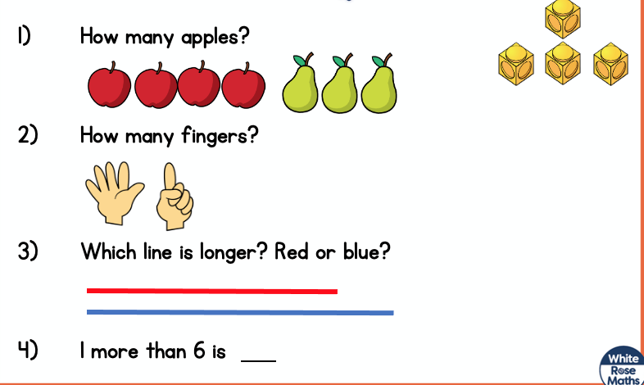
WEEKLY SPELLINGS |  | Write the spellings in your neatest writing |  | HANDWRITING CHALLENGE  Practise the alphabet in cursive writing
1 | sit | 1
2 | sat | 2
3 | pin | 3
4 | pat | 4
5 | hat | 5
6 | in | 6
7 | it | 7
8 | is | 8
9 | dog | 9
10 | cat | 10

WIDER CURRICULUM LEARNING TASKS
1 | Make a collage using Autumn leaves
2 | Put the different types of houses in order from earliest to latest.
3 | Describe the properties of everyday materials.
4 | Practise your happy breathing!
5 | Choose 4 activities from the PE challenge activities.

