Nantwich Primary Academy
“Nurturing every child on the pathway to success!”
Home Learning Tasks for week starting 22/02/21
Did you know, that BBC Bitesize learning is available on the BBC iPlayer?
1-A-DAY READING TASKS |  | POBBLE WRITING TASKS
1 | How to make Teachers Disappear! | 1 | Story Starter
2 | The Pendle Witches | 2 | Sentence Challenge
3 | The Wonderful Wizard of Oz | 3 | Question Time
4 | Trick or Treat | 4 | Sick Sentences
5 | Independent Reading | 5 | Perfect Picture

1-A-DAY MATHS TASKS / VIDEOS
1 | Make Equal Parts
2 | Recognise a half
3 | Find a half
4 | Recognise a quarter
5 | Find a quarter

Maths Problem of the Week
https://nrich.maths.org/2361/note Fair Feast 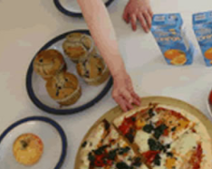

WEEKLY SPELLINGS |  | WEEKLY MATHS FLUENCY |  | HANDWRITING CHALLENGE
1 | other | 1 | Double 5 | 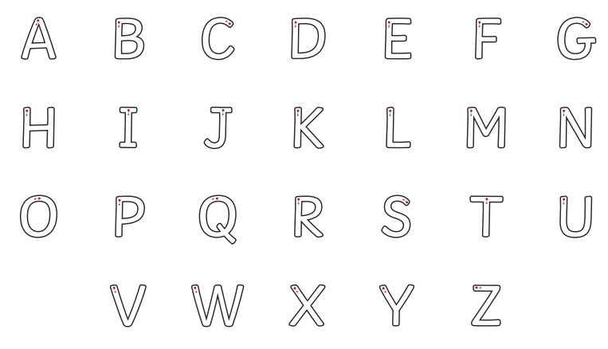
2 | mother | 2 | Double 1
3 | brother | 3 | Double 6
4 | nothing | 4 | Double 2
5 | Monday | 5 | Double 7
6 | money | 6 | Double 3
7 | cover | 7 | Double 8
8 | honey | 8 | Double 4
9 | discover | 9 | Double 9
10 | wonder | 10 | https://www.topmarks.co.uk/maths-games/hit-the-button

WIDER CURRICULUM LEARNING TASKS
1 | I am a geographer! Look at the images in the Africa photo pack.  Create a mind map of the things that you notice.  Did you see anything unexpected? What was of particular interest to you?  Make a note of any questions that you now have.
2 | I am healthy! This week, make an affirmations fortune teller to build your confidence and look after yourself.  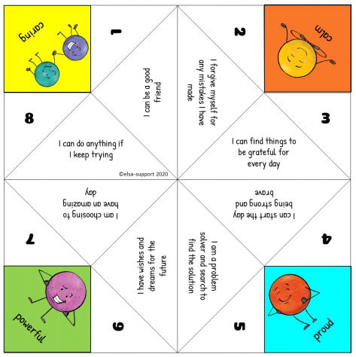  https://www.youtube.com/watch/SAhiIlTxUYA Click on the link for instructions on how to fold your fortune teller.
3 | I am a scientst! This week we will make a start on our mini habitat shoebox model. (This project wil run for 2 weeks). You can make a large habitat or a microhabitat – the choice is yours. Consider the features of a good habitat including opportunity for food, shelter, water, air and protection from predators.  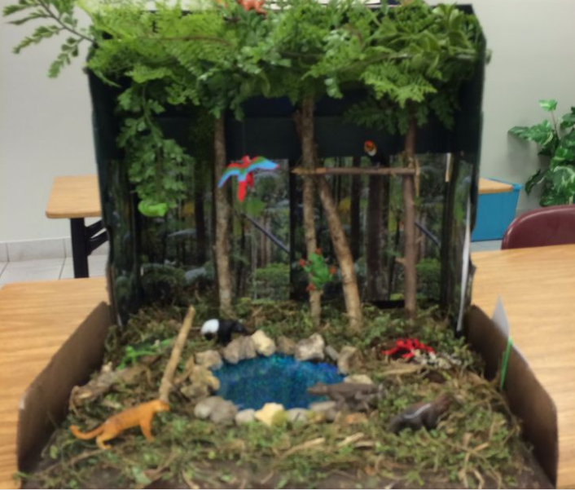 Use real resources from your garden where possible.
4 | I am active! Have fun this week with Coach Corey Martin! Duck and dive on a Jungle chase adventure.  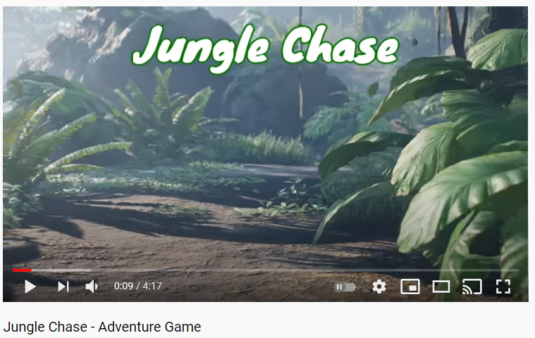  https://www.youtube.com/watch?v=F0VkDf9LyEk
5 | I am an artist! Make a collagraph print.  https://classroom.thenational.academy/lessons/making-a-collagraph-print-c4rk6d?activity=video&step=1  