The seeds of friendship
English week 2
March 1, 2021
Kate Li
NPA
Monday 1st March

Look at this page from the book.
Task 1: Add words to the mind map to describe what Adam thought the snow was like.

wonderful
spectacular

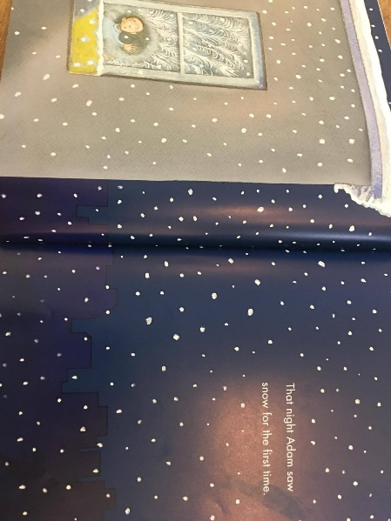
glorious

Today we are going to write an exclamatory sentence.

Needs an exclamation mark
spectacular
Eg. What a sight this is!
Starts with What has a verb
uses and adjective

Another example:
What a wonderful thing to see!

Task 2: Write some exclamatory sentences of your own.

Tuesday 2nd March

These sentence will sequence the events of the morning that Adam played in the snow for the first time.
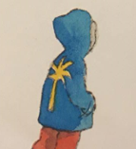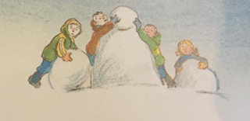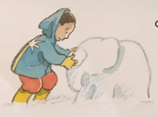

Improve the sentences by adding some of the following:
- adjectives to created expanded noun phrases, (eg. soft, fresh snow)
- adverbs (eg. happily)
- Prepositions (eg. in the street)
- Adventurous verbs(eg. rushed instead of went or explored instead of played)
- Adding extra detail (eg. because, so, but, while, with, that)

Adam went downstairs.
Adam felt cold.
Children were building a snowman.
Adam touched the snow.
He built a snow elephant.
The children threw a snowball at him.

Wednesday 3rd March

The author of our book doesn’t include any dialogue in his text, so today we will be considering what the children might have said to one another at a particular point in the story.
Look at this page in your book.

Eg. Ah! My hands are freezing.
How large should these ears be Adam? I’ve
not seen a real elephant before.

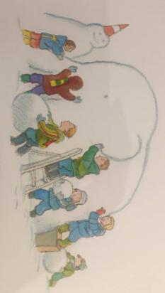
Thursday 4th March

Today we are going to use inverted commas (also known as speech marks) to put the children’s words (that you came up with yesterday), into sentences.

Eg.”Ah! My hands are freezing,” cried Adam.

Inverted commas
.”Ah! My hands are freezing,” cried Adam.
comma full stop

Friday 5th March
Today, we are looking at alternative synonyms for said (words that mean the same, or nearly the same as said).

Try using your voice in different ways to say something. This will help you to generate ideas about what synonyms you could use.

Try different voices for the same idea. Any will work, depending on the situation.
Eg. “It’ my birthday today!” cried Ava.
“It’s my birthday today.” whimpered Ava

Sometimes, it can be silly.
Eg. “I absolutely love my new bike,” groaned Sally.

