Nantwich Primary Academy
“Nurturing every child on the pathway to success!”
Home Learning Tasks for week starting 11/01/21
Did you know, that BBC Bitesize learning is available on the BBC iPlayer?
1-A-DAY READING TASKS |  | POBBLE WRITING TASKS
1 | Stowaway Stefan | 1 | Story Starter
2 | Female Pirates | 2 | Sentence Challenge
3 | A Pirate’s Life For Me | 3 | Question Time
4 | How to make Pirate Stew | 4 | Sick Sentences
5 |  | 5 | Perfect Picture

1-A-DAY MATHS TASKS / VIDEOS
1 | http://vimeo.com/461736938  bonds to 20 worksheet
2 | http://vimeo.com/461836693  compare number sentences worksheet
3 | http://vimeo.com/462380184  know your bonds worksheet
4 | http://vimeo.com/461840544  related facts worksheet
5 | http://vimeo.com/463016488  bonds to 100 (tens) worksheet

WEEKLY SPELLINGS |  | WEEKLY MATHS FLUENCY |  | HANDWRITING CHALLENGE
1 | copying | 1 | ½ of 8 | Use the handwriting card to form your letters using lead lines.
2 | crying | 2 | ½ of 80
3 | replying | 3 | ½ of 4
4 | marrying | 4 | ½ of 40
5 | carrying | 5 | ½ of 6
6 | flying | 6 | ½ of 60
7 | trying | 7 | ½ of 10
8 | drying | 8 | ½ of 100
9 | skiing | 9 | ½ of 2
10 | taxiing | 10 | ½ of 20

WIDER CURRICULUM LEARNING TASKS
1 | Our new science topic is – Habitats! Create a mind map of everything you already know about habitats.  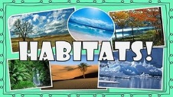
2 | Using the shapes of the continent on the template map of the world. Can you build your own world map? Listen to the 7 continents song on Youtube and learn their names. If you were in school last Monday and made your map, try the challenge questions to see what you can remember.  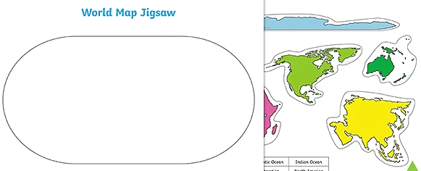  https://www.youtube.com/watch?v=K6DSMZ8b3LE&safe=active
3 | Write at least 1 super sentence that telks the reader a facinating fact about each continent.  Top Tip – The continents song has some information in the lyrics!  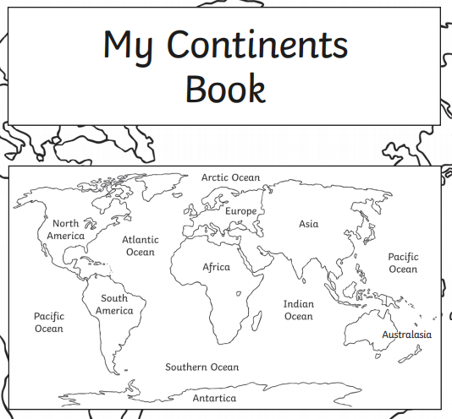
4 | Listen to this example of African music. Have a go at copying the dance moves. We’d love to see your dance videos uploaded to portfolio on class dojo!  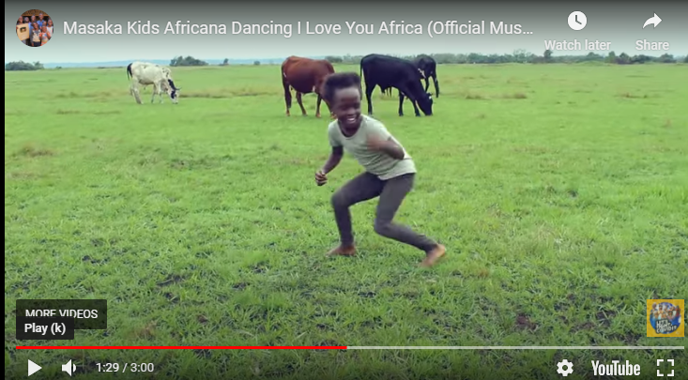  https://www.youtube.com/watch?v=45164iVmhXo&safe=active
6 | Who is your superhero and why? Reflect on those who fill us with gratitude.  Watch the video and complete the superhero task.  You can draw your own or use the template in your pack.  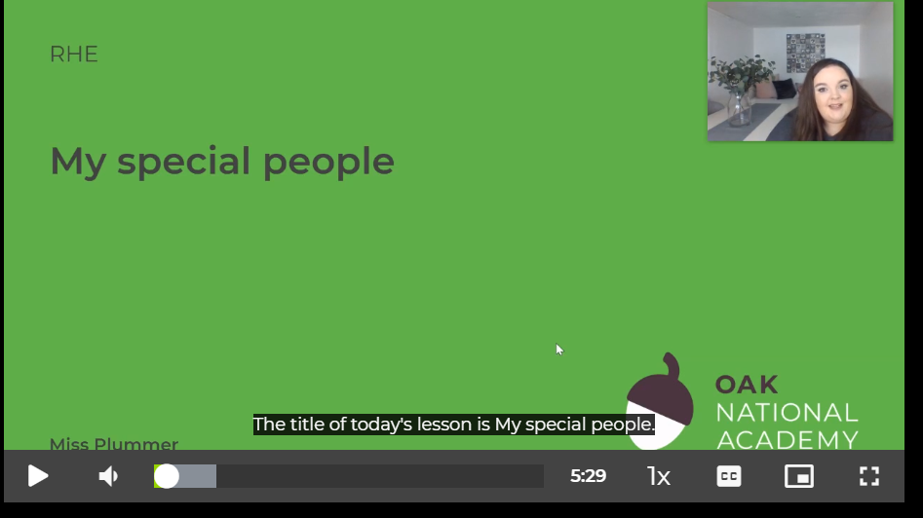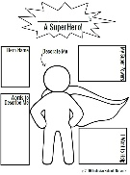  https://classroom.thenational.academy/lessons/my-special-people-69k64c?activity=video&step=1

