Year 2 Homework Autumn Term 1
Homework activities for this half term are described below. You will receive Dojo Points for completing the tasks.
Please bring all completed task in on Wednesdays so we can see what you have been doing.
We look forward to seeing what you have been up to.

1 Dojo Point | 3 Dojo Points | 5 Dojo Points
- Play on TTRS at least 3 times this week. Record this in your reading diaries by writing ‘TTRS’ and we can award your dojos.  - Practise the weekly spelling ready for your test on Fridays. Record this in your reading diaries by writing ‘Spellings’ and we can award your dojos.  - Read your book at least 4 times per week and share your ‘Love to Read’ book with a family member. Record this in your reading diaries with a signature and we can award your dojos. | - RE – Write about how you were welcomed into the world. Perhaps you were baptised or had a different special ceremony. Maybe friends and family came to see you to celebrate your birth.  - SCIENCE – Take inspiration from The Wright Brothers. Can you design a paper plane? How far can it fly? Try making changes to improve the design. Make a record of how long it stays in the air or the distance it travelled.  - HISTORY - Create a fact file on Queen Victoria. Who was she? What inspirational things did she do? How did she help to ensure that the Victorians were Victorious?  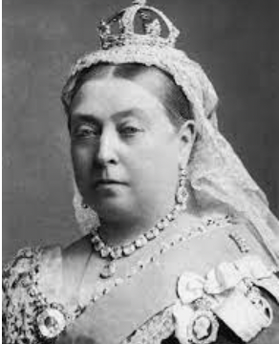 | - COMPUTING – Create a collage of photos that you have taken on a theme of your choice. Maybe you are inspired by nature or perhaps you like portrait photography.  - ART – Go outside and create an Andy Goldsworthy inspired sculpture of your own. Take a photo of your masterpiece to create a lasting memory. Annotate your work to share your thoughts and ideas.  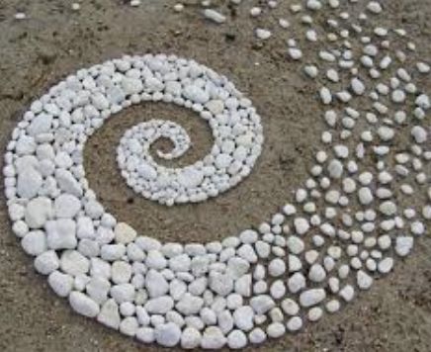  - PSHE – Create a poster that celebrates who you are! Why is it good to be you? What do you enjoy doing? What are your aspirations for the future? Who do you enjoy spending time with?

