WB: Monday 1st March
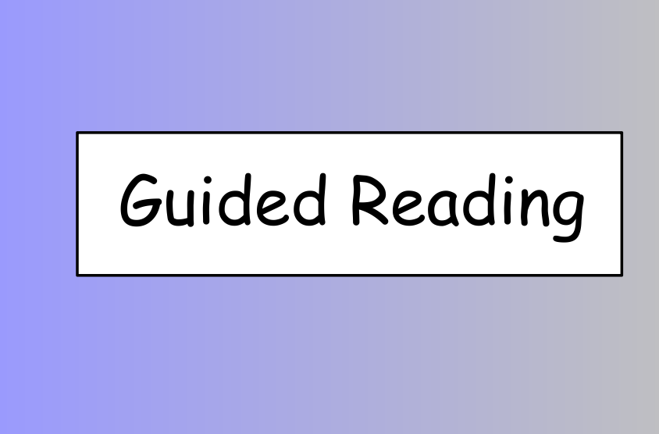

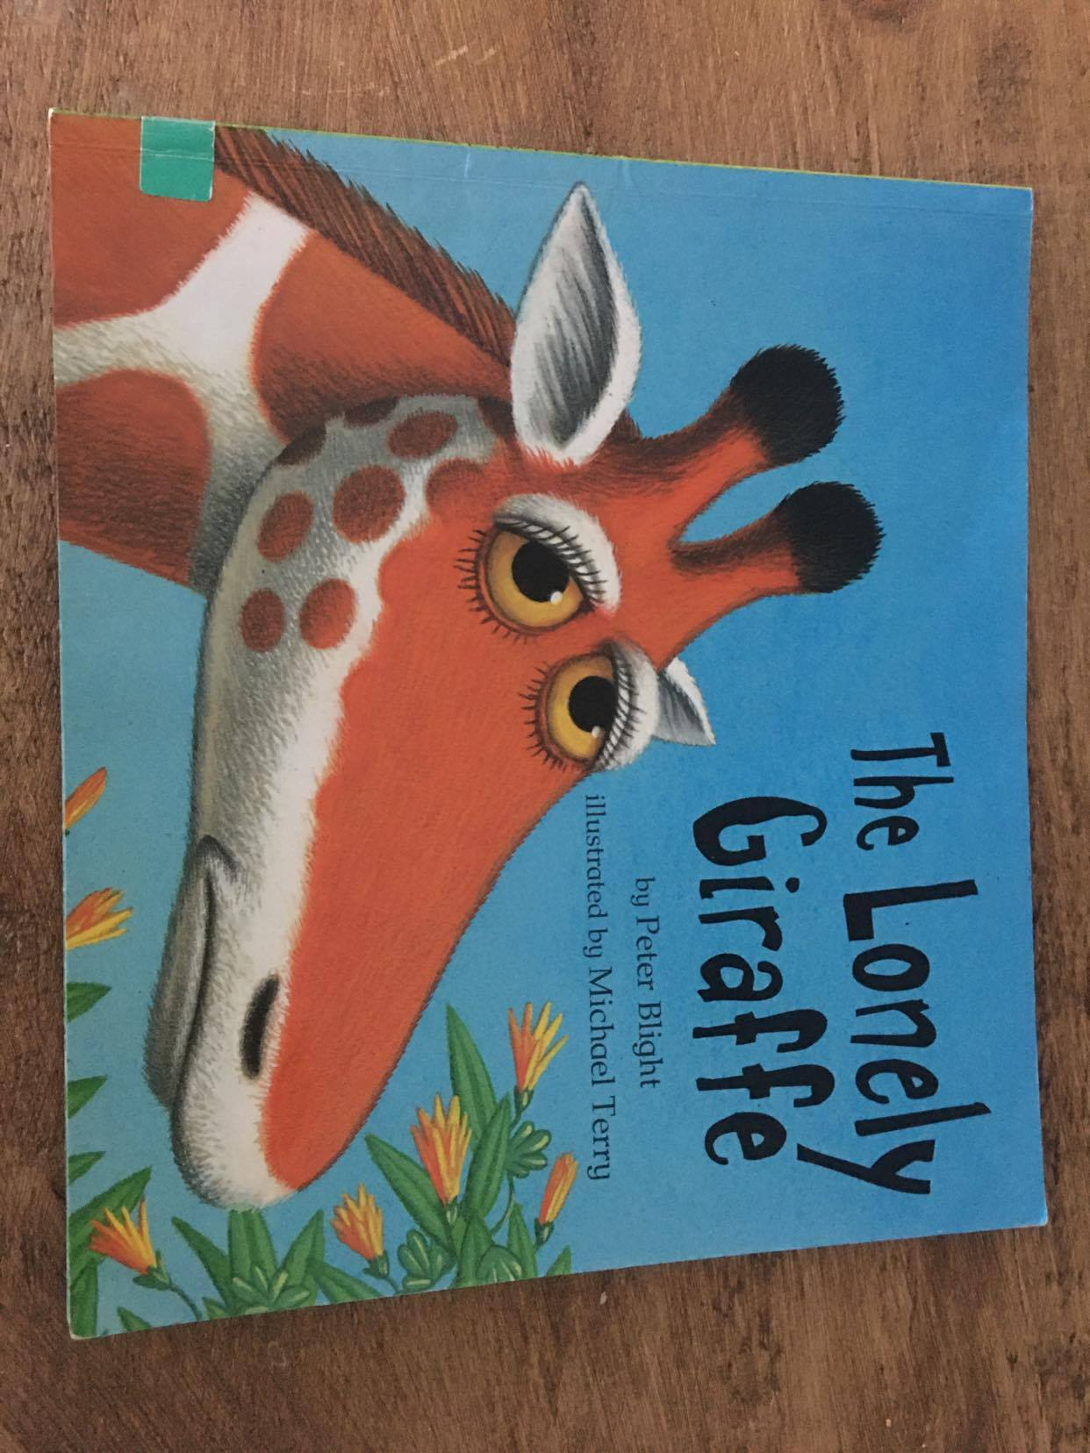

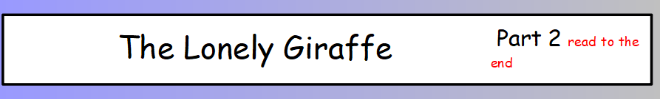

Parents – You can read part 1 of the text first, while your child follows and listens to the story. This helps them to hear the story structure and follow the events without worrying about decoding the words.

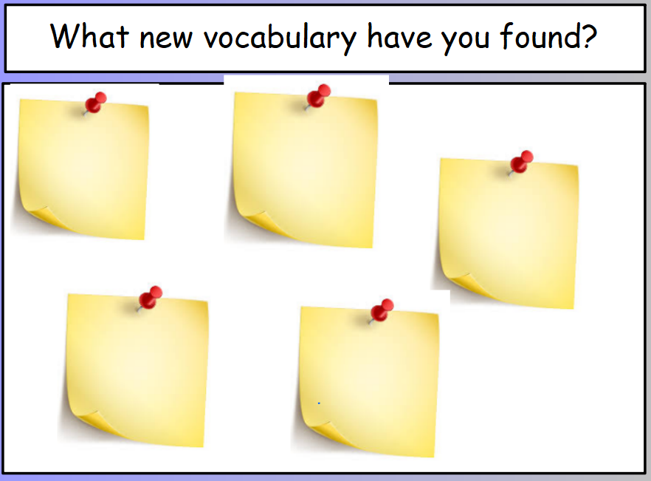

Ask your child if there were any words that they are unsure of the meaning.
Record them on the post-it. Sometimes it can help to act out the meaning of the word or use it in different sentences.

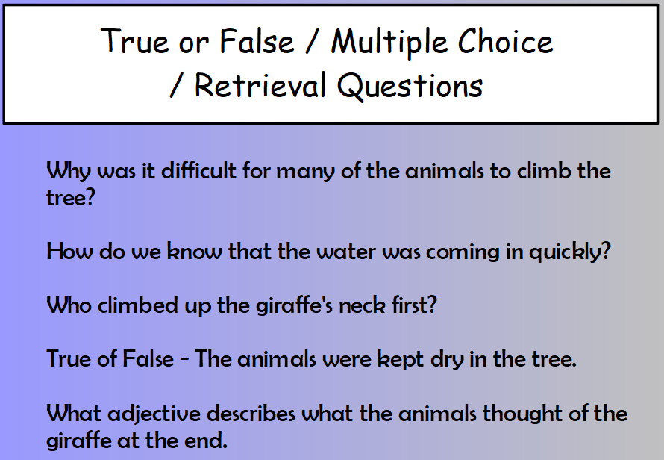

These responses can be written down if you wish, but a verbal discussion is just a useful.

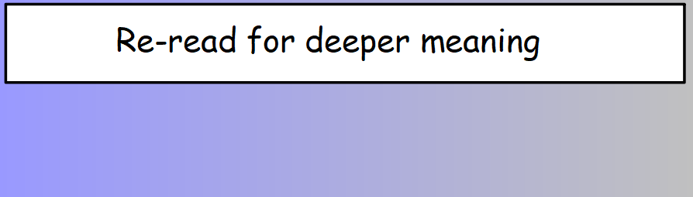

Now it is your child’s turn to read, while you listen.

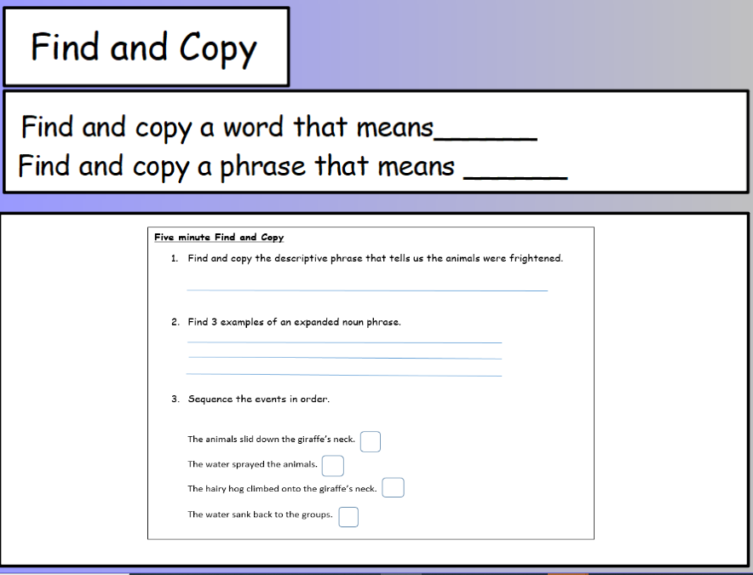

Written activity 1 – Find and Copy

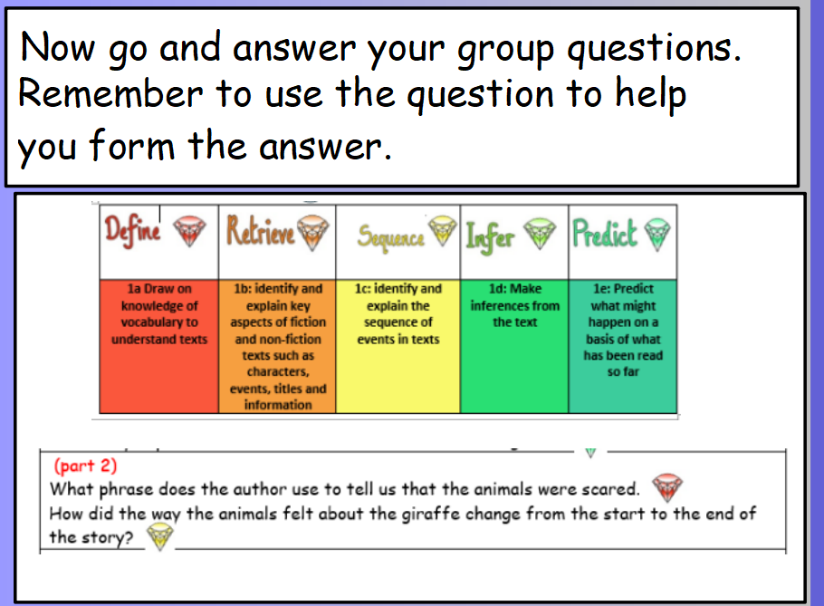

Written activity 2: Reading Gems.
(Reading Gems are used in school to ensure that the children become familiar with the different types of comprehension questions used to develop understanding of texts.
Eg. question 2 – How did the way the animals felt about the giraffe change from the start to the end of the story? This is a sequence question as it requires the children to use the order of the story and draw evidence from the beginning and the end considering how things changed over time.

