Nantwich Primary Academy
“Nurturing every child on the pathway to success!”
Home Learning Tasks for week starting 01/03/21
Did you know, that BBC Bitesize learning is available on the BBC iPlayer?
1-A-DAY READING TASKS |  | POBBLE WRITING TASKS
1 | A Scarecrow’s Job | 1 | Story Starter
2 | Turning Milk into Cheese | 2 | Sentence Challenge
3 | The Little Red Hen | 3 | Question Time
4 | Farmyard Babies | 4 | Sick Sentences
5 | Independent Read | 5 | Perfect Picture

1-A-DAY MATHS TASKS / VIDEOS
1 | Recognise a third
2 | Find a third
3 | Unit fractions
4 | Non-unit fractions
5 | Equivalence of ½ and 2/4

Maths Problem of the Week
https://nrich.maths.org/154/clue Biscuit decorations

WEEKLY SPELLINGS |  | WEEKLY MATHS FLUENCY |  | HANDWRITING CHALLENGE
1 | key | 1 | Double 50 | 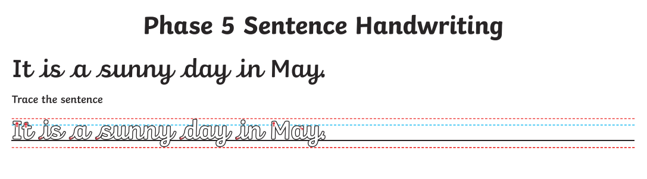
2 | donkey | 2 | Double 10
3 | monkey | 3 | Double 60
4 | chimney | 4 | Double 20
5 | valley | 5 | Double 70
6 | trolley | 6 | Double 30
7 | turkey | 7 | Double 80
8 | hockey | 8 | Double 40
9 | parsley | 9 | Double 90
10 | journey | 10 | https://www.topmarks.co.uk/maths-games/hit-the-button

WIDER CURRICULUM LEARNING TASKS
1 | I am a geographer!  This week you will research African food and try out a simple African inspired lunch. Many fruits are grown in Africa, so an fruit salad is a good option. You might also like to try baking bread. Maybe you’d like to try a Chapati (East African bread).  A recipe for this in included in your pack but feel free to explore other options.
2 | I am healthy! Take time out this week to look after your mind. Use the colouing techniques to mindfulness.  Your bookmark will fold in the middle and become 2 sided. When you return to school, we will be happy to laminate it for you.  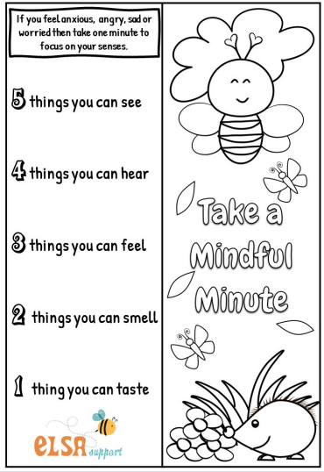
3 | I am a scientst! This week we will continue work on our mini habitat shoebox model. (This project is running for 2 weeks). You can make a large habitat or a microhabitat – the choice is yours. Consider the features of a good habitat including opportunity for food, shelter, water, air and protection from predators.  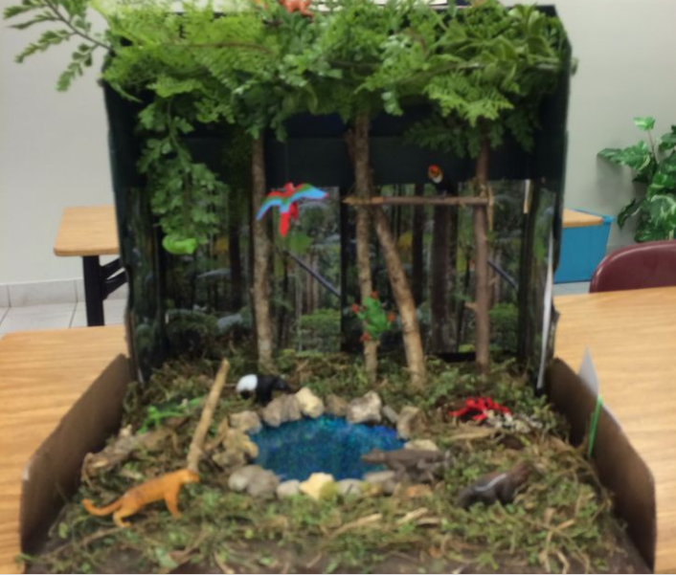 Use real resources from your garden where possible.
4 | I am active! Get moving this week and work out with Corey Martin.  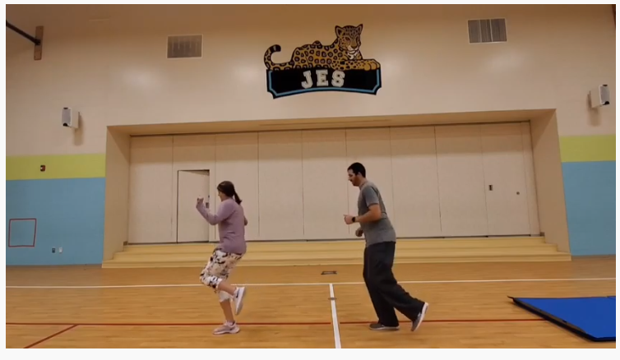  https://www.youtube.com/watch?v=YreuINfBl10
5 | I am an artist! This is the final session in your art printing series. This week you will look at the work of Natasha Maksimovic and use your own prints to present your own collage.  https://classroom.thenational.academy/lessons/reviewing-and-presenting-our-printmaking-work-c9jk6d?activity=video&step=1  